**Student: Kim Junghwan**

**Student ID: 2020312434**

**Course Section Number: SWE3048-42**

**WEB PROJECT**

**REPORT**

**[Fitconnect]**

**0. How to Run it?**

1. Extract the contents of the compressed file.
2. Open any file inside the 'html' folder in the 'public' directory using the 'Open with Live Server' option."

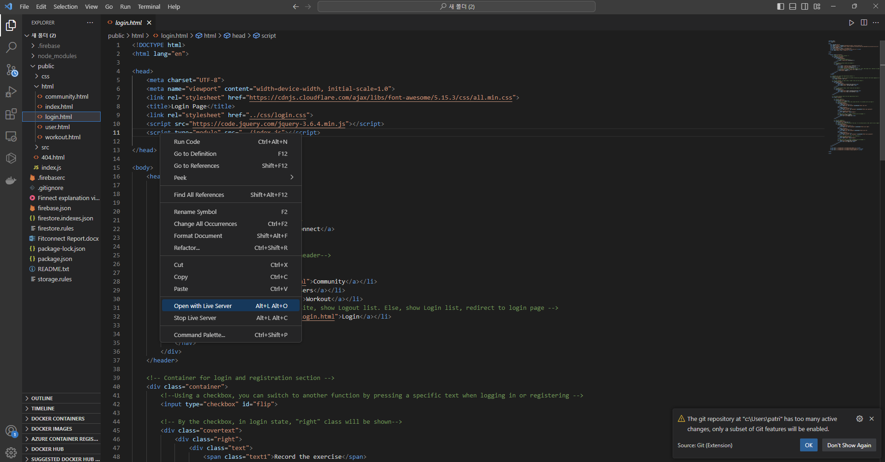

**1. Login Page**

[Main Function]

* Users on the login page can perform the following activities:
  + logging in / signing up.
* Login: System checks if the user has appropriately entered their ID and password. If the ID exists in the database and the password matches, the user is automatically redirected to the **[Main Page]**.
* Sign Up: When signing up, users need to input their name, ID, and password. The ID length is limited to a maximum of 10 characters. If the ID is unique, the user's signup information is stored in the database, and they are automatically redirected to the **[Main Page]**.
* Upon successful login or signup, the user's ID is stored in session storage for subsequent use on specific pages.
* When a user successfully logs in, the text 'Login' in the header changes to 'Logout.'
* By clicking on it, the user can log out. At this point, the ID information stored in session storage is removed.

**2. Main Page**

[Main Function]

* Providing information about this website and offering motivation for exercise, users are introduced to the community feature.
* 텍스트, 스크린샷, 사람, 의류이(가) 표시된 사진

  자동 생성된 설명텍스트, 스크린샷, 폰트, 인쇄이(가) 표시된 사진

  자동 생성된 설명This page offers a responsive design. Utilizing **display: grid**, it adjusts the number of columns based on screen size, ensuring elements adapt appropriately to different screen sizes.
* used an iframe to embed YouTube videos within the HTML.
* While Introducing the community feature, it was designed to assist users in utilizing this function.
* The 'Move to Community' button allows users to easily navigate to the **[Community Page]**.
* At the bottom, there's copyright information and an icon button that redirects to the creator's GitHub, providing an avenue for interested users to explore more.

**3. Community Page**

[Main Function]

* On this page, users can view previously written posts. Additionally, they can read comments posted on the viewed articles. If logged in, users have the ability to leave comments. Moreover, for logged-in users, there is an option to create new posts.
* On this page, users can communicate through posts and comments on any topic, whether related to exercise or not.
* If logged in, users have the following actions available to them:
  + viewing posts, creating posts, viewing comments, and leaving comments.
* If not logged in, users can still perform the following actions:
  + viewing posts and viewing comments.
* To check if a user is already logged in, retrieve the user ID from the session storage.

**4. User Page**

[Main Function]

* On this page, you can retrieve information such as the user ID, the number of exercises recorded this month, and personalized greetings for each user registered on the website. Additionally, there is a button to view the exercise records for a specific user.
* If the user is logged in, an edit icon will be added next to their personalized greeting.
* Through this icon, the user can modify their greeting. If not modified, the default greeting is "Let's workout!"
* If not logged in, no icon will be displayed.
* You can view the user's exercise records by clicking the "View Exercise Records" button.
* When user click the "View Exercise Records" button, the selected user's ID is stored in the session storage. This information is used when accessing the user's record details.

**5. Workout Page**

[Main Function]

- On this page, users can view their own exercise records, select a date, and add exercise details such as type and duration for that day.

- Additionally, if redirected through a specific page, users can also browse through the exercise records of other users.

- The functionality is divided into three main parts: a clickable calendar, a section for adding exercise records, and a section for viewing exercise records.

- The currently selected date on the calendar is highlighted with a red border, and this border changes each time a different date is clicked.

- The dates on which exercise records are written feature a flame image inserted as the background, visually indicating to users on which dates exercise records have been created.

- When recording exercise, it is divided into general and detailed entries.

- In the general entry, users record the type of exercise and the duration.

- For detailed entries, this pertains to fitness. By clicking the "+" icon in Fitness, users can enter more specific details about the exercise. In this scenario, it involves recording the weight and number of repetitions for each set, spanning a total of 텍스트, 바퀴, 스크린샷, 타이어이(가) 표시된 사진
four sets.

(a) If the user presses the "Workout" button in the header and enters the Workout page.

- If the user is not logged in, a message is displayed indicating the need for login, and the user is redirected to the **[Main Page]**.

- If logged in, this page displays the exercise records of the logged-in user.

- In this scenario, the user can add their exercise records or delete exercise records for a specific date.

(b) If entered through the "View Exercise Records" button on the **[User Page].

- In this scenario, users can view exercise records even without logging in.

- However, since the user is not the owner of the exercise record, they cannot add or delete exercise records.

**6. Database using Firebase**

**-** Within the Firebase database, there exist three collections:

1. The "post-page" collection stores information related to the posts created by users, including the content of the posts and comments associated with them.

2. The "user-info" collection is created during user registration and stores details such as the user's name, ID, password, and other relevant information.

3. The "workout-record" collection is created during user registration with the user's ID as the document ID. It contains a map called "details," where the keys are dates, and the corresponding values are arrays storing the detailed exercise records for each respective date.

